**Explain React Events**

React events are similar to native DOM events (like onclick, onchange) but are wrapped in React’s own system called the Synthetic Event system.  
They allow you to handle user interactions (like clicks, typing, or form submissions) in a consistent way across all browsers. Instead of directly modifying the DOM, React events update the virtual DOM and re-render UI elements efficiently.

**Explain About Event Handlers**

Event handlers are **functions** that are executed when a specific event occurs in React (like button click or input change).

* In React, event handlers are usually defined as class methods or arrow functions in functional components.
* They are passed to JSX elements as attributes.  
  Example:

jsx

<button onClick={handleClick}>Click Me</button>

Here, handleClick is an event handler for the onClick event.

**Define Synthetic Event**

A Synthetic Event in React is a cross-browser wrapper around the native browser event. It normalizes event properties and behavior to make event handling consistent across different browsers.

* It contains the same properties as native events (target, type, etc.).
* Example:

jsx

function handleClick(event) {

console.log(event.type); // Synthetic event type

}

**Identify React Event Naming Convention**

React uses camelCase naming for event attributes instead of lowercase. Also, you pass a function reference, not a string.

* Example (Correct in React):

jsx

<button onClick={handleClick}>Click</button>

* Example (Incorrect, native HTML way):

html

<button onclick="handleClick()">Click</button>

**CurrencyConverter.js**

import React, { Component } from "react";

class CurrencyConverter extends Component {

  constructor(props) {

    super(props);

    this.state = {

      rupees: "",

      euro: "",

      rate: 0.011, // Example: 1 INR = 0.011 Euro (adjust as needed)

    };

  }

  handleChange = (event) => {

    this.setState({ rupees: event.target.value });

  };

  handleSubmit = (event) => {

    event.preventDefault(); // Prevent page reload

    const euroValue = (this.state.rupees * this.state.rate).toFixed(2);

    this.setState({ euro: euroValue });

  };

  render() {

    return (

      <div style={styles.container}>

        <h2>Currency Converter (INR to EURO)</h2>

        <form onSubmit={this.handleSubmit}>

          <input

            type="number"

            placeholder="Enter amount in INR"

            value={this.state.rupees}

            onChange={this.handleChange}

            style={styles.input}

          />

          <button type="submit" style={styles.button}>

            Convert

          </button>

        </form>

        {this.state.euro && <p>Euro: €{this.state.euro}</p>}

      </div>

    );

  }

}

const styles = {

  container: {

    marginTop: "30px",

    textAlign: "center",

  },

  input: {

    padding: "8px",

    marginRight: "10px",

    fontSize: "16px",

  },

  button: {

    padding: "8px 15px",

    fontSize: "16px",

    cursor: "pointer",

  },

};

export default CurrencyConverter;

**App.js**

import React, { Component } from "react";

import CurrencyConverter from "./CurrencyConverter";

class App extends Component {

  constructor(props) {

    super(props);

    this.state = {

      counter: 0,

    };

  }

  // Increment handler invoking multiple methods

  handleIncrement = () => {

    this.incrementCounter();

    this.sayHello();

  };

  incrementCounter = () => {

    this.setState((prevState) => ({ counter: prevState.counter + 1 }));

  };

  sayHello = () => {

    alert("Hello! Counter incremented.");

  };

  // Decrement handler

  handleDecrement = () => {

    this.setState((prevState) => ({ counter: prevState.counter - 1 }));

  };

  // Function with argument

  sayWelcome = (message) => {

    alert(message);

  };

  // Synthetic Event Handler

  handleSyntheticEvent = (event) => {

    event.preventDefault(); // Demonstrating synthetic event

    alert("I was clicked");

  };

  render() {

    return (

      <div style={styles.container}>

        <h1>React Event Examples</h1>

        {/* Counter Section */}

        <h2>Counter Value: {this.state.counter}</h2>

        <button style={styles.button} onClick={this.handleIncrement}>

          Increment

        </button>

        <button style={styles.button} onClick={this.handleDecrement}>

          Decrement

        </button>

        {/* Welcome Button */}

        <button

          style={styles.button}

          onClick={() => this.sayWelcome("Welcome to React Events!")}

        >

          Say Welcome

        </button>

        {/* Synthetic Event Button */}

        <button style={styles.button} onClick={this.handleSyntheticEvent}>

          Synthetic Event

        </button>

        {/* Currency Converter Component */}

        <CurrencyConverter />

      </div>

    );

  }

}

const styles = {

  container: {

    textAlign: "center",

    fontFamily: "Arial",

    marginTop: "20px",

  },

  button: {

    margin: "10px",

    padding: "10px 20px",

    fontSize: "16px",

    cursor: "pointer",

  },

};

export default App;

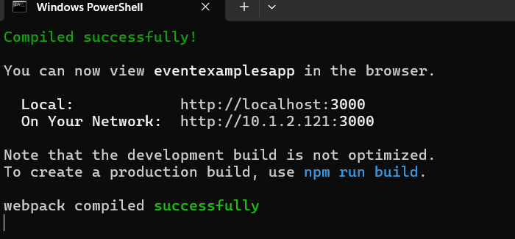

**OUTPUT ON THE BROWSER**

